Exercise 1: Mocking and Stubbing
Scenario:
You need to test a service that depends on an external API. Use Mockito to mock the external API and stub its methods.
Pom.xml:
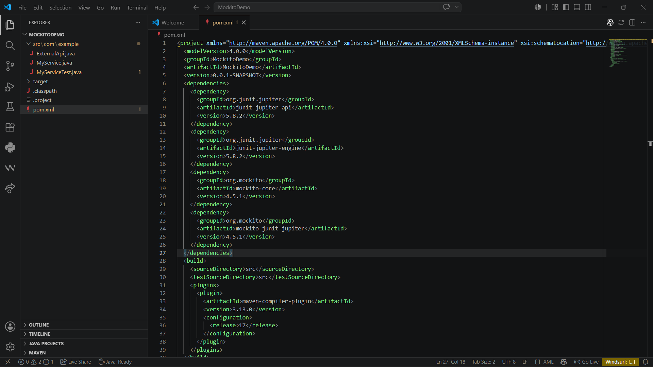
MyService.java:
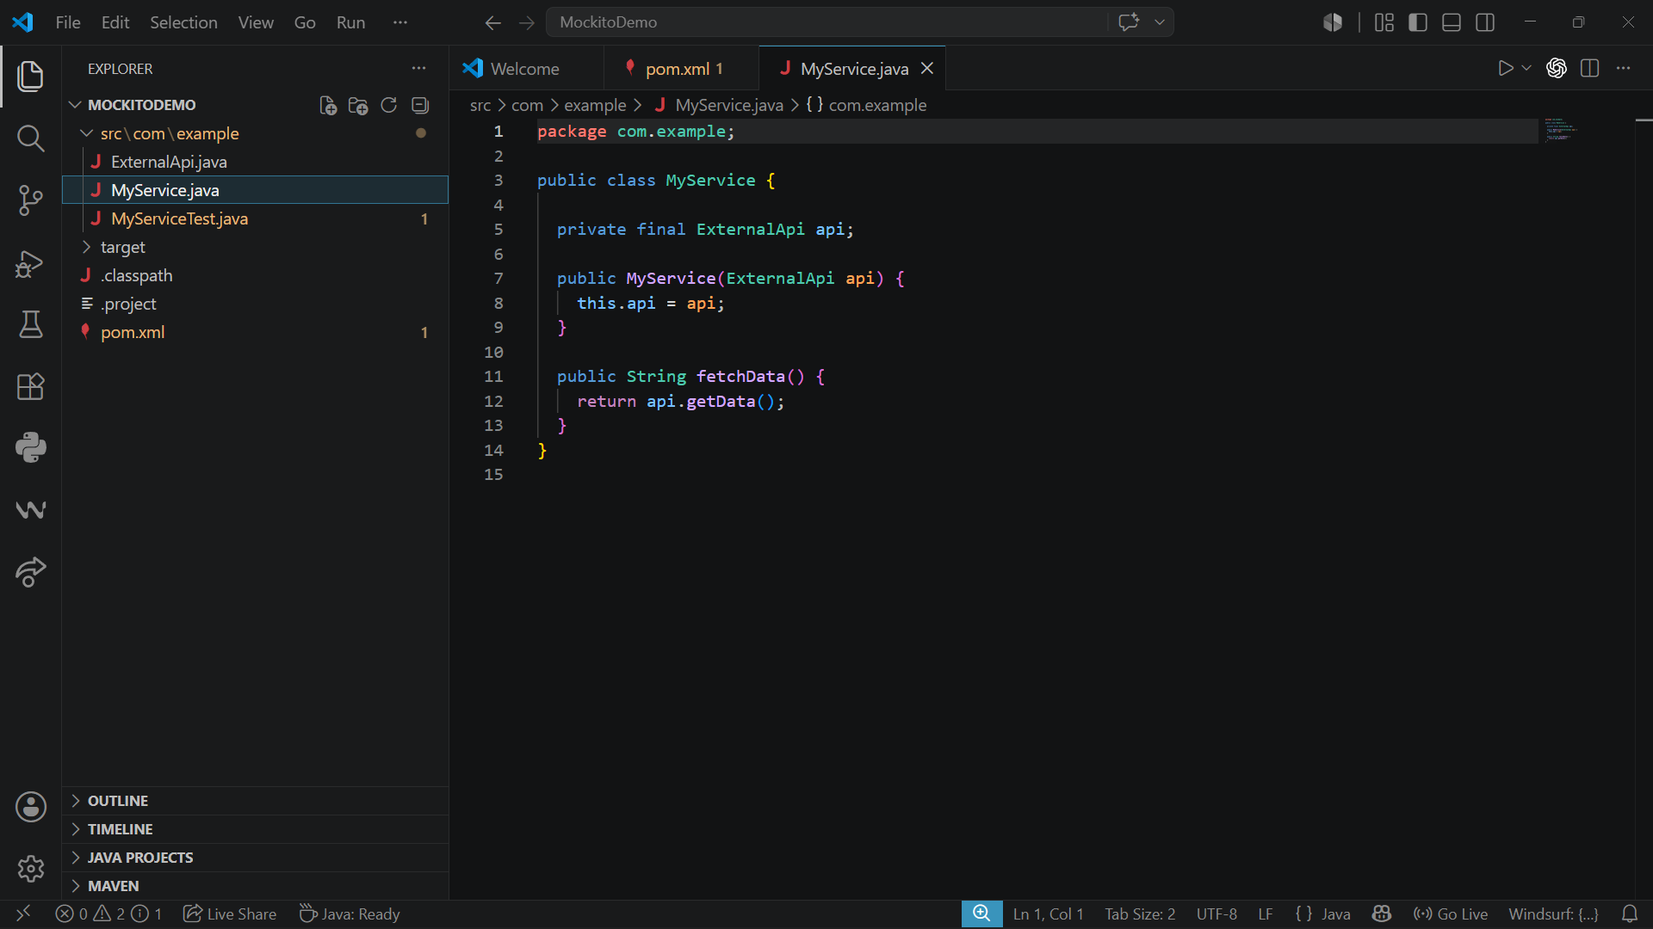

MyServiceTest.java:
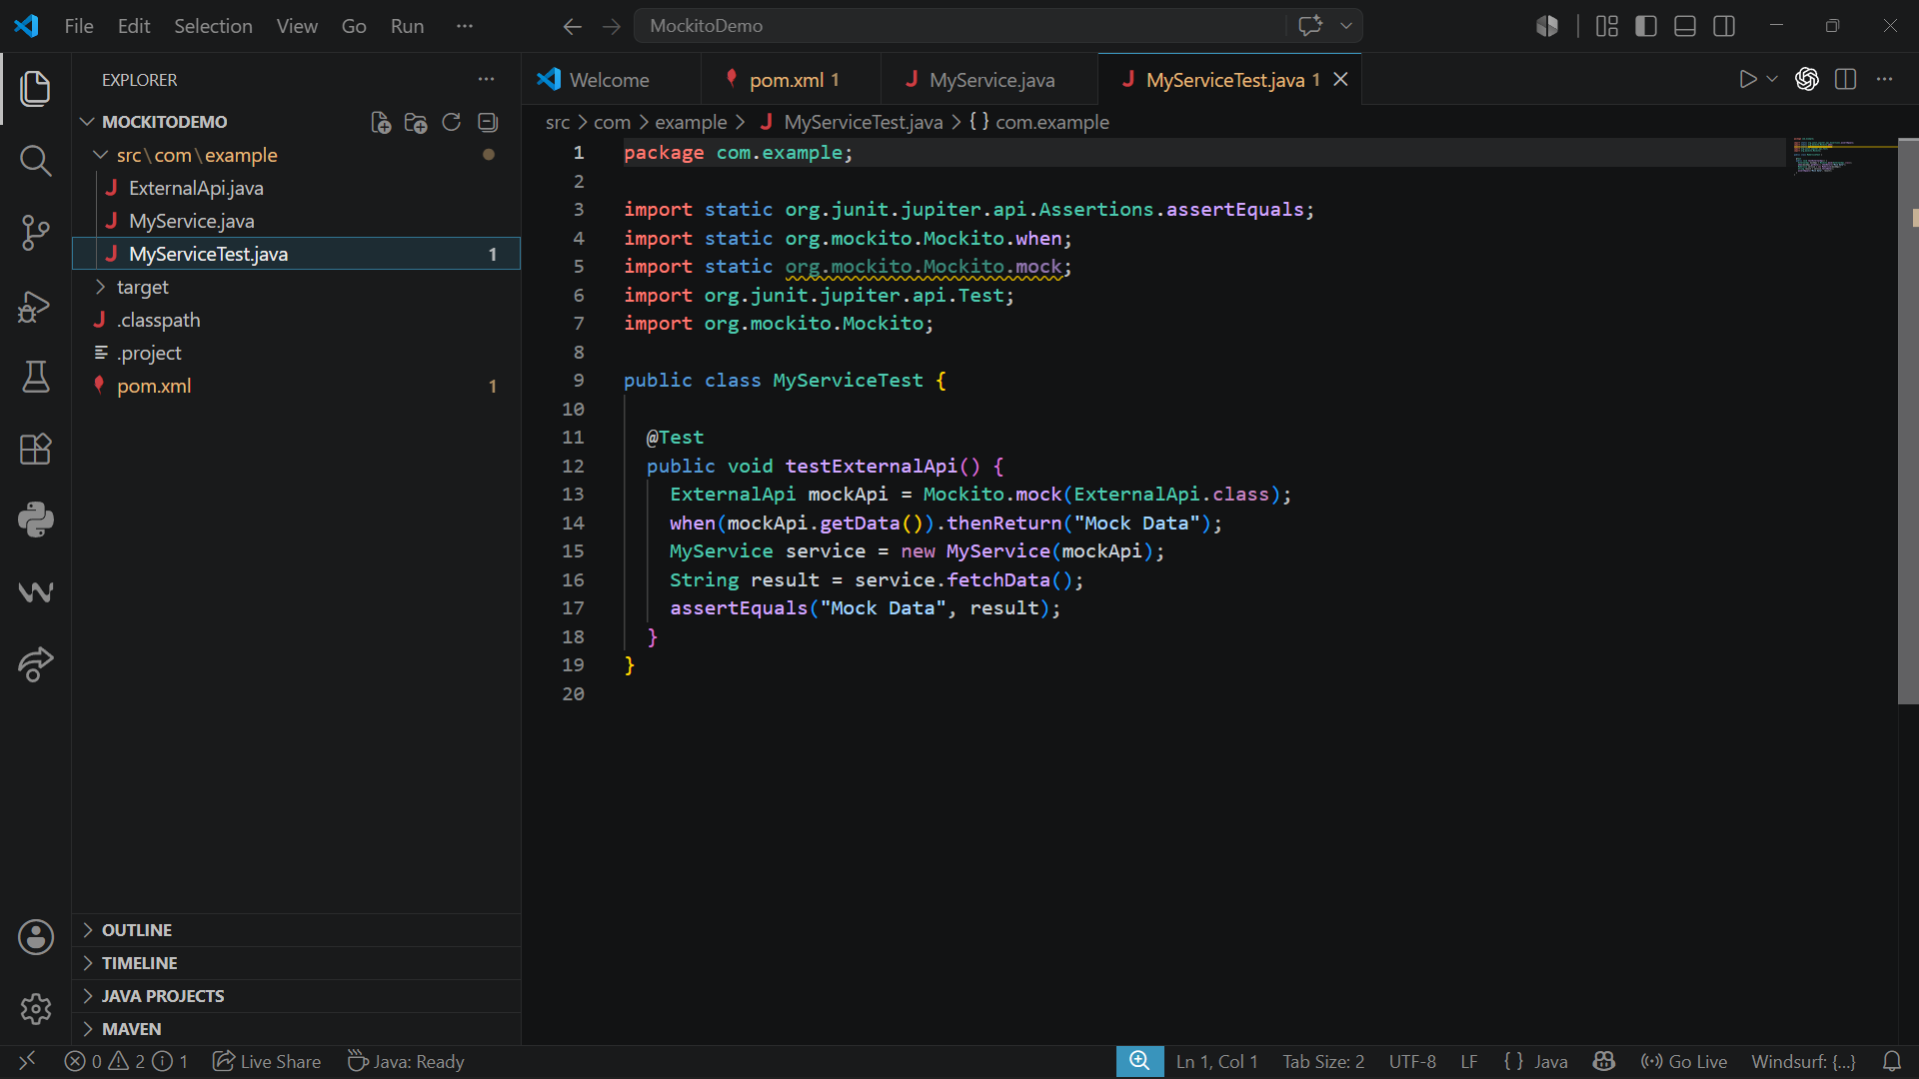
Output:
